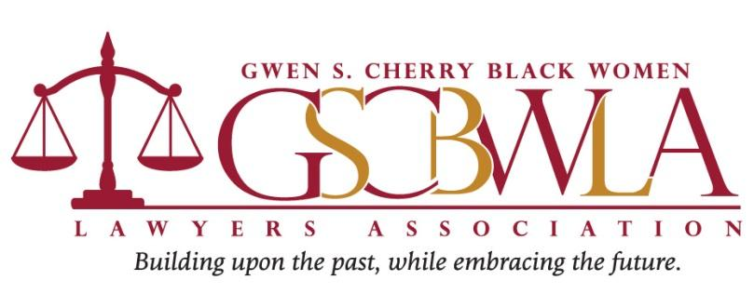

2022 BOOK SCHOLARSHIP APPLICATION
Gwendolyn Sawyer Cherry was born in Miami, Florida in 1923. For approximately 22 years, she taught in the Dade County (now Miami-Dade) Public Schools. She became a pioneer of the State of Florida's legal profession. She received her undergraduate degree from Florida Agricultural Mechanical University (“FAMU”). She later returned to FAMU to obtain her Juris Doctorate degree and serve as a professor at its law school. She was admitted to The Florida Bar in 1965. She was the first Black woman to practice law in Dade County, Florida. She was one of the first nine attorneys who initially served at Legal Services of Greater Miami in 1966. In 1970, Ms. Cherry was elected as a state representative, becoming the first Black woman to serve as a legislator for the State of Florida.

The Gwen S. Cherry Black Women Lawyers Association (GSCBWLA), formerly the National Bar Association Women Lawyers Division Dade County Chapter, was formed in 1985. The association's mission is to address the concerns of women lawyers as they relate to the social, economic, political and moral needs of the community.

The Gwen S. Cherry Black Women Lawyers Association is committed to investing in the future of the legal profession. This year’s scholarships are available to current law students attending law schools throughout Florida that will assist them in buying books for class or for bar review.

Eligibility Requirements:
- Must be currently enrolled in a Florida law school;
- Must complete the attached scholarship application;
- Write a short essay of 500 words or less responding to the Writing Prompt; and
- Provide a professional headshot photograph to be included in the Awards Ceremony program if chosen as a scholarship recipient.

Winners of the GSCBWLA 2022 Book Scholarship Award will be announced at the
Gwen S. Cherry Black Women Lawyers Association’s Installation & Awards Ceremony on Thursday, June 16, 2022 (in-person event).
Applications MUST be submitted via email to info@gscbwla.org
no later than 11:59 p.m. on Friday, June 3, 2022

2022 BOOK SCHOLARSHIP APPLICATION
Applications MUST be submitted via email to info@gscbwla.org
no later than 11:59 p.m. on Friday, June 3. 2022

APPLICANT NAME:

MAILING ADDRESS:

EMAIL:

PHONE NUMBER:

EXTRACURRICULAR ACTIVITIES and/or COMMUNITY SERVICE:

CURRENT LAW SCHOOL:

EXPECTED GRADUATION DATE? Month: Year:

Please attach a copy of your resume.

WRITING PROMPT:

History has been written and forever changed by the well-deserved and long-awaited confirmation of Judge Ketanji Brown Jackson, the first Black woman to serve as an Associate Justice of the United States Supreme Court. As this well-qualified jurist spoke about her journey to the highest court in the land, she shared her family life, moments of adversity, unique career path, undeniable brilliance, and unyielding perseverance. Together, we watched and rejoiced in solidarity as Judge Brown Jackson shattered a glass ceiling that once served as a barrier to Black women lawyers in this country.

As Justice Brown Jackson takes her position as Supreme Court Justice, the work begins. Discuss the impact that Justice Jackson is likely to have on the ideological makeup of the United States Supreme Court based on her personal and professional background, and discuss how her work is likely to affect the legal profession, Black women lawyers, and communities of color as a whole.

Explain your answer in 500 words or less. For questions, please email info@gscbwla.org.

Thank you for applying. All winners will be notified prior to the June 16, 2022 Installation and Awards Ceremony, and invited to attend this year’s in-person event in South Florida.

